**Ahead of the International Women’s Day on 8th March….**

**FOCUS 24/7 Newspaper Honors Eminent Sierra Leonean Women**

Sierra Leone, like many countries around the world, celebrates the International Women’s Day on the 8th March each year.

This day is dedicated in honouring the achievements and contributions of women in various fields and highlighting the ongoing struggle for gender equality. This year’s celebration, the management and staff of Focus 247 Newspaper is set to celebrate some remarkable women who have made significant impacts in their respective fields.

Among these eminent women are Her Excellency Mrs. Fatima Maada Bio, Dr. Sylvia Blyden, Justice Miatta Samba, Mayor Aki-Sawyer, President of the Women in the Media Sierra Leone, sama Kamara James, the Head of the National Revenue Authority Madam Jeneba Bngura.

Her Excellency Mrs. Fatima Maada Bio, Fatima Maada Bio entered politics in 2007. In 2018, she became First Lady when her husband was elected as President of Sierra Leone. As First Lady, she has been involved in various initiatives focused on education, women’s empowerment, and child welfare.



She has also been a vocal advocate for gender equality and has worked to promote access to education for girls and women in Sierra Leone. Fatima Maada Bio has received several honors and awards for her humanitarian work and advocacy. In 2018, she was awarded an honorary doctorate degree from the University of East London in recognition of her contributions to education and women’s empowerment. She has also been recognized by various organizations for her work in promoting gender equality and improving access to education for girls and women.

The Hands of Our Girls (HUG) campaign is a flagship initiative of H.E. Mrs. Fatima Maada Bio, aimed at tackling issues affecting the education and empowerment of adolescent girls in Sierra Leone. The campaign was launched in June 2018, with the goal of reducing teenage pregnancy rates, increasing school attendance and retention, and promoting gender equality.

prior to entering politics, Her Excellency Mrs. Fatima Maada Bio worked in the banking and finance industry in both Sierra Leone and the United Kingdom. She also established the Sierra Leone War Victims Fund, which aimed to provide support for victims of the country’s civil war. In addition to this, she has been involved in various humanitarian efforts, including working with the Hinga Norman Foundation and the Conflict Prevention and Peace Forum.

Estina Tailor is the President of the Women in the Media Sierra Leone (WIMSAL), an organization that aims to empower women in the media industry and promote gender equality in the country’s media sector. 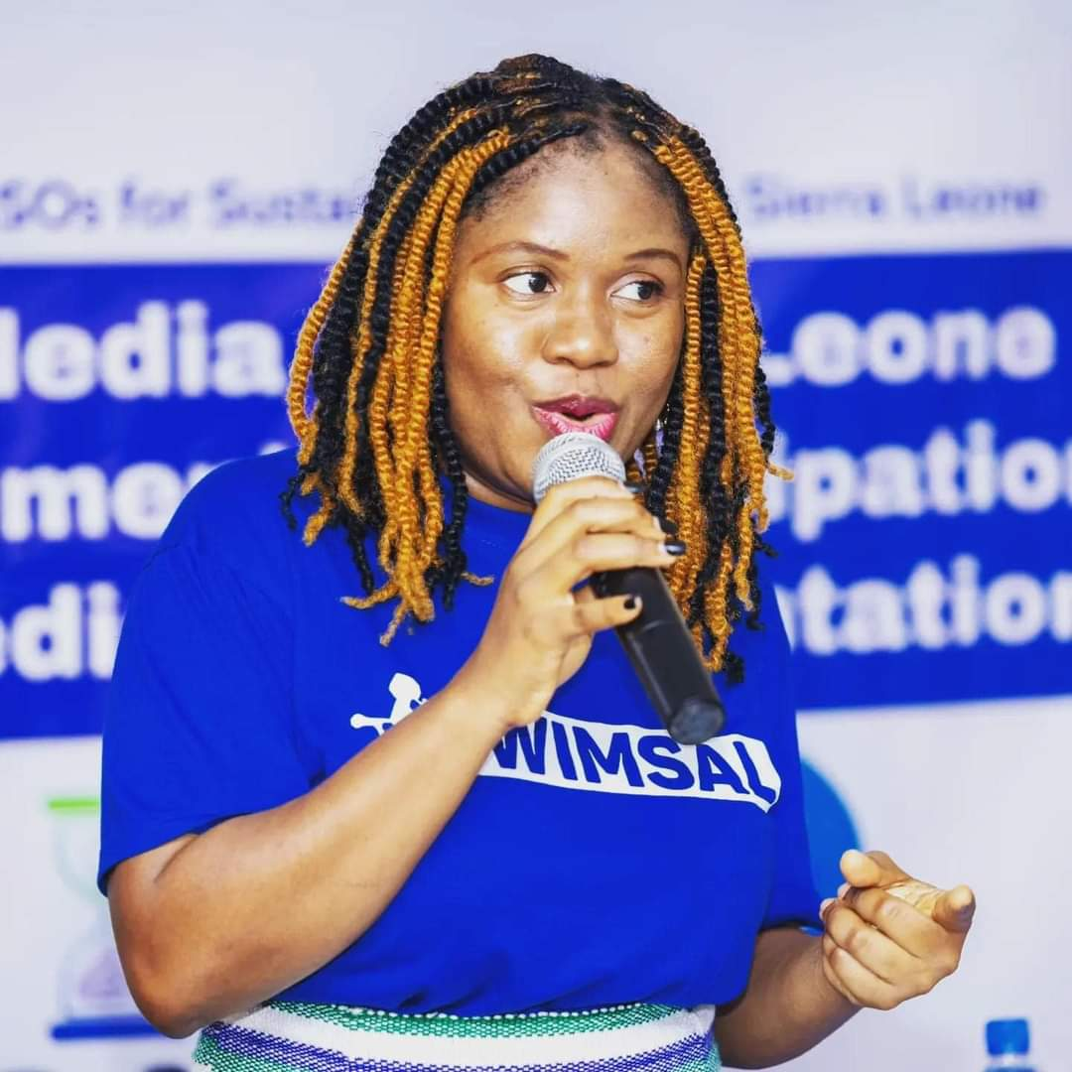

She has made a tireless advocate for women’s rights and has worked to ensure that women’s voices are head in the media. Under Tailor’s leadership, WIMSAL has launched several initiatives aimed at promoting women’s participation in the media. These include training programs for women in journalism, media literacy campaigns and advocacy efforts aimed at increasing the number of women in decision-making positions in the media industry. Tailor is also a prominent broadcaster and has worked as a radio presenter and producer for many years. She has used her platform to raise awareness about important social issues, including gender-based violence, women’s empowerment and human rights.

Nabela F. Tunis is the Minister of Tourism and Culture and she is a prominent figure in the tourism and cultural sector of Sierra Leone.

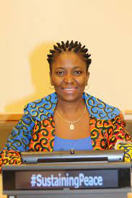

She has been serving as the Minister of Tourism and Cultural Affairs for a significant period, during which she has made substantial contributions to the development and promotion of tourism and cultural heritage. Before her appointment as the Minister of Tourism and Cultural Affairs, Nabela F. Tunis held various positions in both the public and private sectors. She has extensive experience in tourism and cultural affairs, having worked in various capacities in museums, cultural institutions, and tourism boards. Her background in cultural heritage and tourism management has been instrumental in shaping her approach to promoting cultural tourism and preserving cultural heritage. As Minister of Tourism and Cultural Affairs, Nabela F. Tunis has implemented various initiatives to promote tourism and cultural heritage. She has focused on developing sustainable tourism practices, preserving cultural heritage sites, and promoting cultural exchange programs. Under her leadership, the tourism sector has seen significant growth, with an increase in both domestic and international tourists. Nabela F. Tunis has promoted cultural exchange programs to foster understanding and cooperation between different cultures. These programs have provided opportunities for individuals from different cultures to learn about each other’s traditions, customs, and values. This has helped to promote tolerance, respect, and understanding between different cultures.

Augusta James Teima is the first female to hold the distinguished position as Minister of Sport of Sierra Leone. She was appointed to this position by His Excellency President Julius Maada Bio.

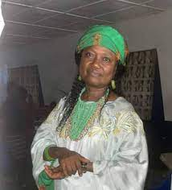

Teima is a former athlete and has a deep passion for sports. She has been instrumental in promoting sports development and physical education in Sierra Leone. As the Minister of Sport, Teima is responsible for promoting sports development and physical education in Sierra Leone. She oversees the administration of sports programs, facilities, and events in the country. She also works closely with various sports organizations, both local and international, to promote sports development and enhancing the performance of Sierra Leonean athletes.

Melrose Karminty Minister of Social Welfare is the current Minister of Social Welfare and since her appointment she has contributed immensely in championing issues affecting women and children in the country.

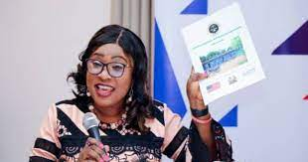

Melrose Karminty is a prominent Sierra Leonean women who is now serving the country diligently in addressing issues affecting women and girls and advocating for gender equality in the country.

Dr. Sylvia Blyden is a prominent figure in Sierra Leone known for her work as a journalist, activist and politician. She has been a vocal advocate for women’s rights and social justice issues in the country. Sylvia Blyden has also served in various government positions, including as Special Executive Assistance to the former President Ernest Bai Koroma, she has served as Minister of Social Welfare Ministry.

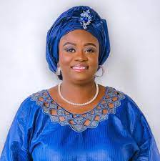

Notable, Sylvia Blyden has been prominent advocate for women’s rights and has a sound knowledge in national issues and she is well-grounded in the politicking of the country. Many of her admirer has considered her as a potential President of the Republic of Sierra Leone. May be, in the 2028 elections, Sylvia Blyden would contest for the flagbearer position in the main opposition APC party.

Marcella Samba is a prominent figure in Sierra Leone known for her work with the Campaign for Good Governance (CGG) in the country. CGG is a non-governmental organization that focuses on promoting transparency, accountability, and good governance practices in Sierra Leone. The main objective of Campaign for Good Governance (CGG) in Sierra Leone to hold the government accountable and promote transparency in public affairs. The CGG engages in advocacy, research, and civic education to empower citizens and strengthen democratic governance in the country.



Marcella Samba has been actively involved in advocating for good governance and social justice in Sierra Leone. She has been a vocal critic of corruption and inefficiency in government institutions, pushing for reforms to improve the lives of ordinary citizens. Marcella Samba’s work with the CGG has had a significant impact on promoting good governance practices in Sierra Leone. Through advocacy campaigns, policy recommendations, and community engagement, she has helped raise awareness about the importance of accountability and transparency in government. Despite their efforts, Marcella Samba and the CGG face various challenges in their work, including resistance from government officials, limited resources, and political interference. However, they remain committed to their mission of promoting good governance and fighting corruption in Sierra Leone.

Mayor Yvonne Aki-Sawyerr is a prominent Sierra Leonean humanitarian, and development expert.

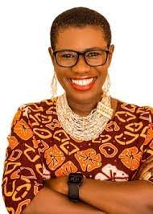

She made history on April 25, 2018, when she became the first woman to be elected as the Mayor of the Freetown Municipality, the capital city of Sierra Leone. Her election marked a significant milestone for the country, as it demonstrated the progress made towards gender equality in leadership positions. Mayor Aki-Sawyerr’s election has had a profound impact on gender equality in Sierra Leone. Her success has inspired many women to pursue careers in politics and leadership, breaking down barriers and challenging traditional gender roles. Additionally, her leadership has shown that women can be effective and successful leaders in traditionally male-dominated fields. She has been a trailblazer in local governance and urban development, implementing initiatives to improve the lives of residents of Freetown and promoting sustainable development in Freetown. Undoubtedly, Mayor Aki-Sawyer has been a distinguished personality who have served as a motivation to other women to compete for positions that are male dominant. Her eloquence and dedication to work has given her advantage over her competitors.

Justice Miata Samba is a prominent figure in Sierra Leon’s legal system, serving as a judge in the High Court. She has made significant contributions to the country’s judiciary throughout her career. Throughout her tenure as a judge, she has presided over numerous high-profile cases and has been instrumental in shaping the country’s legal landscape.

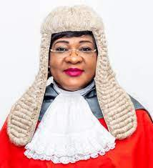

Her experience and knowledge have earned her respect from both her peer and members of the general public. In addition to her judicial duties, Justice Samba has been actively involved in various capacities within the legal community. She has served as a member of the Sierra Leone Law Reform Commission and has contributed to the development of legal frameworks and policies in the country. Furthermore, she has participated in regional and international legal forums, sharing her insights and experiences. Justice Miata Samba’s commitment to upholding the rule of law and ensuring justice for all has been widely acknowledged. Her contributions to the Sierra Leonean judiciary and legal system have been invaluable, and she continues to serve as a beacon of integrity and professionalism in the country’s legal system. Justice Miatta Samba is a respected legal figure in Sierra Leon who has made significant contributions to the country’s judiciary system. She has been instrumental in upholding the rule of law and in promoting justice in Sierra Leone. She is among few women that are distinguished in the Sierra Leone legal system.

Madam Jenba Bangura is the current Head of the National Revenue Authority in Sierra Leone. She plays a crucial role in overseeing the collection of revenue for the government of Sierra Leone. As the head of this authority, she is responsible for implementing tax policies, ensuring compliance with tax laws, and maximizing revenue collection to support government programs and services. Madam Jeneba’s leadership at the National Revenue Authority is essential for promoting transparency, accountability and efficiency in revenue collection processes.

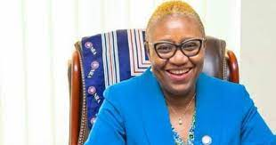

Her Strategic decision making and management skills are instrumental in driving sustainable economic growth and development in Sierra Leone. Under Madam Jeneba Bangura guidance, the National Revenue Authority works towards enhancing tax compliance, reducing tax evasion and fostering a culture of voluntary tax payment among individuals and businesses. Her efforts contribute significantly to strengthening the country’s fiscal position and promoting financial stability. It is no joke that her elevation as head of NRA did not come as a surprise to many.

Madam Asama Kamara James is a prominent figure in Sierra Leone’s media landscape. She is known for her contributions to journalism and her active involvement in advocating for press freedom and media ethics in the country. Asama Kamara James has been a vocal voice in addressing issues related to media professionalism, government accountability and social justice through her work in various media outlets.

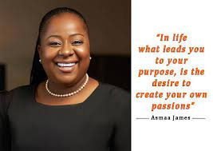

Asama Kamara James began her career in journalism several years ago, working for reputable media organizations in Sierra Leone. She has covered a wide range of topics, including politics, human rights and social issues. Her reporting style is characterized by thorough research, balanced reporting and a commitment to upholding journalistic integrity. Throughout her career, Asama Kamara James has conducted interviews with key political figures, civil society leaders and community members to shed light on important issues facing Sierra Leone. Her work has been instrumental in raising awareness about corruption, inequality, and other challenges that the country faces. Asama Kamara James before establishing her Rise radio station, she has served as Station Manager and presenter of the popular radio program in Sierra Leone, ‘Gud Morning Salone’.

Hon. Veronica Kadie Sesay is a prominent figure in Sierra Leonean politics and has been actively involved in advocating for women’s rights and empowerment. Her role as a female member of Parliament highlights the progress that Sierra Leone has made towards achieving gender parity in political representation.

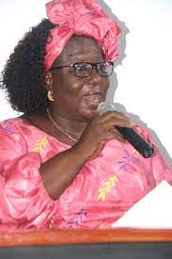

There are other women that are also playing significant role in the informal sector and this medium will ensure that they are recognized in our subsequent publications.

As its 25th Anniversary Celebration approaches**…**

**RCBank Holds Colourful Marketing Parade at Bo City**

Ahead of its 25th Anniversary Celebration, one of the leading financial institutions in Sierra Leone, Rokel Commercial Bank, has organized a colourful marketing Parade on Saturday 2nd March 2023, in Bo Town, Southern Province of the Republic of Sierra Leone.

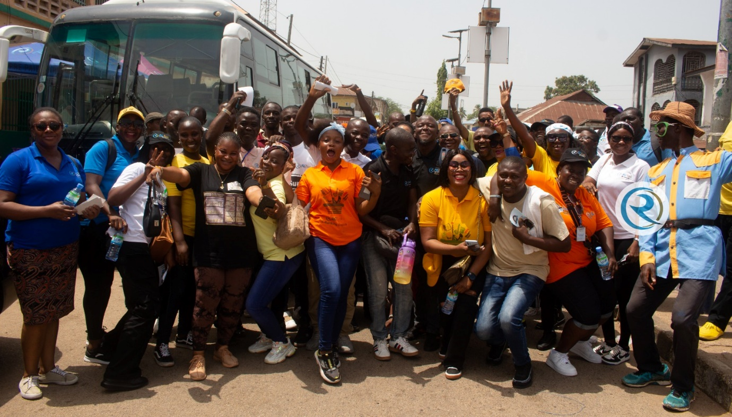

The parade, stretching from Dambala Road to the bank’s branch in Bojon Street in Bo, aimed at not only meeting with its customers in Bo but to sensitize the public about the bank’s digital products and their myriad benefits to customers.

The well-attended event, saw a convergence of senior and junior bank staff, accompanied by RCBank’s Director of Risk Management, Madam Millicent Cole who joined staff of the Bank and volunteers navigating the streets of Bo to disseminate information on RCB’s digital offerings. The parade was adorned with the sounds of Sierra Leonean music and the lively ‘BUBU’ dance, providing entertainment for both staff and onlookers, while effectively conveying the bank’s message.

The Host Branch Manager of RCBank Bo, Mr. Alpha Barrie appreciated the support from management, the Risk Director and from managers like Mr. John Nicol of the Kenema Branch, Mr. Mahamed Daramy Kamara of Moyamba, Mr. Saidu Paul Conteh of Pujehun Branch and other senior management staff from Freetown including Mrs. Veronica Williams, Mr. Umaru Shyllon, Mrs. Mariama Jajua, Mr. Bai Turay, Mr. Alie Kargbo, Mrs. Karina Gbakie and Mr. Sandi Massaquoi. Mr. Barrie also commended and appreciated staff that were present to make the float parade and marketing campaign a success.

This ground-breaking event brought together diverse stakeholders, including staff from the Bank’s Branches in Freetown and Bo, customers, and community residents, to showcase RCBank products and services and foster strong bond between its Bo customers and staff of the Bank.

As Over 800 Participants and vehicles were moving in an orderly fashion, the procession ceremony created a Platform for customers to get a comprehensive understanding of the Bank’s various Services.

Engaging residents of Bo, Brand Ambassador of RCBank Brand Ambassador, Kindo Armani highlighted the bank’s commitment to digitalization, showcasing initiatives such as ATM cashless transactions, issuance of Visa Prepaid Cards, and the integration of services like Simkorpor and E-Korpor. These advancements, he noted, streamline tasks, enhance efficiency, reduce errors, and expedite processing times.

In the Bank’s previous Marketing Parade held in Freetown on 10th February 2024, the Managing Director Dr. Gilpin assured that RCB would extend its sensitization efforts nationwide, ensuring every Sierra Leonean gains a comprehensive understanding of Digital Banking, Cybersecurity, and the benefits of going cashless.

The engagement ended fruitfully. Hence, the Parade, underscores their dedication to embracing the digital era and ensuring every citizen is equipped with the knowledge to navigate the evolving landscape of modern banking as it proved to be ideal.

As such a gathering will create opportunities for senior and junior staff of the bank to meets with customers and residents of their various areas of Operations which could further strengthen the relationship on the basis for truth, transparency as good administration for RCBank and even other institutions.

As Rokel Commercial Bank takes strides in digitization, their dynamic approach to public awareness underscores their dedication to embracing the digital era and ensuring that all citizens have the opportunity to access, be knowledgeable and to navigate the evolving landscape of modern banking. **RCBank – The Bank of Choice and Integrity!!!!!!**

**Director at the Ministry of Finance Charged to Court**

By Bonnke Fofanah

Joseph Ngegba, a Director at the Ministry of Finance Inventory Unit has made his first appearance before Magistrate Sahr Kekura of Pademba Road Magistrate Court No.1, in Freetown.

The accused was arraigned before the court on four count charges to wit trespass, malicious damage, threatening language and intimidation, all contrary to the laws of Sierra Leone.

When the charges were read and explained to him, he pleaded not guilty.

According to the police charged sheet, the accused person on the 11th May 2023, at No.2 River off Peninsular Road in Freetown, unlawfully encroached in an annoying manner upon the land situated lying and being at No.2 River off Peninsular Road Freetown belonging to Alhaji Dauda the complainant.

Furthermore, it was alleged on count two that on the above said date and place in Freetown, the accused did maliciously damage an iron gate on the above said land valued fifty thousand Leones (Le50,000), property of Alhaji Dauda.

Police sheet revealed by claiming that, on the same date and place in Freetown, the accused did make use of threatening language against the complainant with intent to annoy him.

It was further alleged that, the accused on the above mentioned date and place in Freetown did intimidate the above said complainant in an effort to prevent him from going about his lawful business.

The complainant, Alhaji Dauda, testified in court that he came to know the accused in respect of the matter. He recalled on the 11th May 2023, he was hosting workers at the said site at No.2 wherein they were trying to fix up a gate to secure the land. He further stated that the accused person together with other individuals came with thugs, machetes in their hands and disrupted their work.

He stated that the accused threatened him that "Dis na we government en nobody nor go do me anything or even question me sef." The complainant further mentioned that the accused ordered his men to chase him out of the land. He also told the court that he went and reported the matter at the Lumley Police Station to the Land Grabbing Unit. He added that, together with Inspector Edward Conteh they also visit the crime scene and snapshot were taken and statement was obtained from him.

At this juncture, the prosecutor sought for a short adjournment date for his client.

The Defence Counsel made an application for bail for and on behalf of the accused person. However, the prosecuting counsel objected to the bail application.

Meanwhile, Magistrate Kekura granted accused person bail in the sum of one hundred thousand Leones (Le100,000) with one surety, and such surety must be employed and resident in Freetown. And the bail should be approved by the Master and Registrar. The matter was adjourned to the 13th of March, 2024.

**First Lady Calls for Gender Equality**

Her Excellency Mrs. Fatima Maada Bio has called for global cooperation for gender equality and a united effort to end violence and bigotry against women and girls.

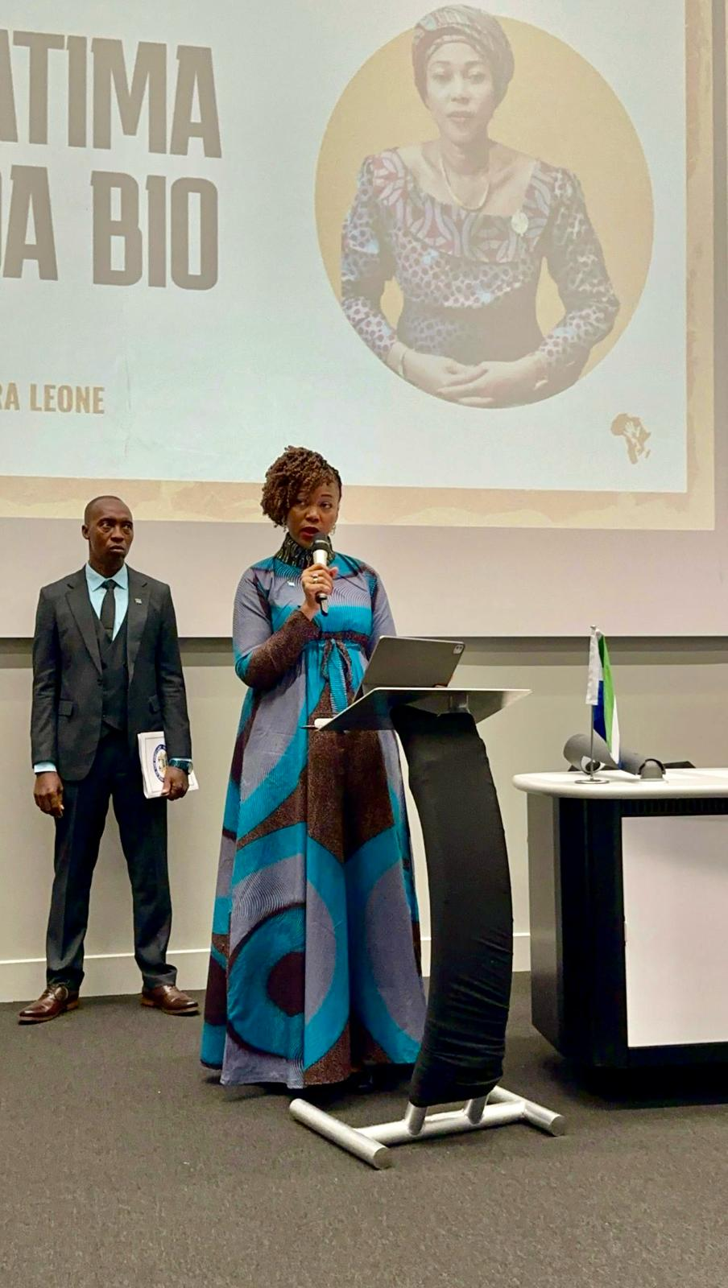

The charismatic First Lady of the Republic of Sierra Leone, Her Excellency Dr. Fatima Maada Bio, made this statement whilst delivering her speech at the Warwick University auditorium in Coventry, England, followed by an engaging question- and-answer session.

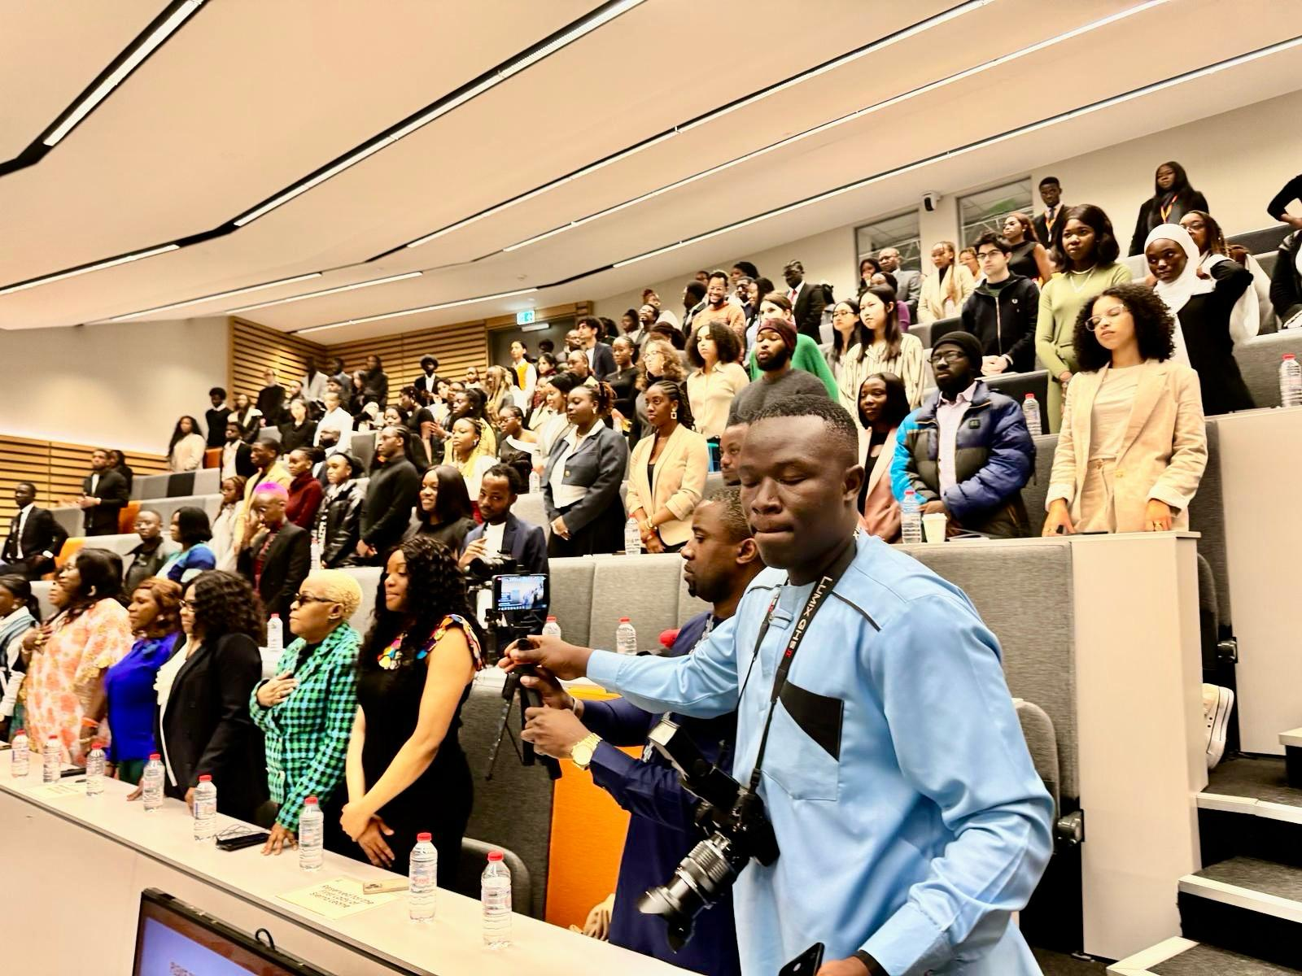

Addressing a diverse audience comprising students, academics, administrators, and other distinguished guests, Mrs. Bio passionately underlined the need for Africans, at home and abroad, to work together to develop the continent. She also used the opportunity to urge policymakers, community leaders, and other stakeholders worldwide to intensify their efforts in combatting and eradicating violence and bigotry against women. She encouraged women and girls to believe in themselves and to work hard on breaking any barriers that may be holding them back and hindering their progress.

In this captivating keynote address, punctuated by rounds of enthusiastic applause, Mrs. Bio inspired the youths to dream big, explore widely, push forward and unite to overcome obstacles.

Reflecting on her personal journey, Mrs. Bio expressed gratitude to HE President Julius Maada Bio, for empowering her and for the strong support and encouragement she continues to receive.

The First Lady advocated for hard work, perseverance, and fearlessness in the pursuit of justice and righteousness, while also emphasising the transformative power of education. She further encouraged African students, and all who love Africa, to help change the negative narrative about Africa, look to the continent’s huge potentials and seek to leverage strong partnership for meaningful growth.

This enlightening speech, delivered on the concluding day of a two-day summit, was part of a line-up of events, which included panel discussions on various topics revolving around the theme "UMuntu Ngumuntu Nag Bantu," a Zulu/Xhosa expression meaning “I am because you are”.

Organized by African students and students of African origin, the Warwick Africa Summit is a leading collegiate society in the UK which bills itself as “an embodiment of African pride that transcends geographical confines”, and aims to serve as a “catalyst for change and development on the continent by fostering dialogue and innovation” in positive minds, to carve a better future for everyone. They work to connect “African leaders, innovators and entrepreneurs to a global talent-pool of individuals”.

**Ambassador Ishata Thomas Advocates for More Scholarship Quota for Sierra Leone**

Sierra Leone Ambassador to the State of Kuwait, Her Excellency Haja Ishata Thomas, has held fruitful discussions with Dr. Jassim Al-hamdan, Dean of Students Affairs of the University of Kuwait in an effort to increase the admission quota for Sierra Leonean students.

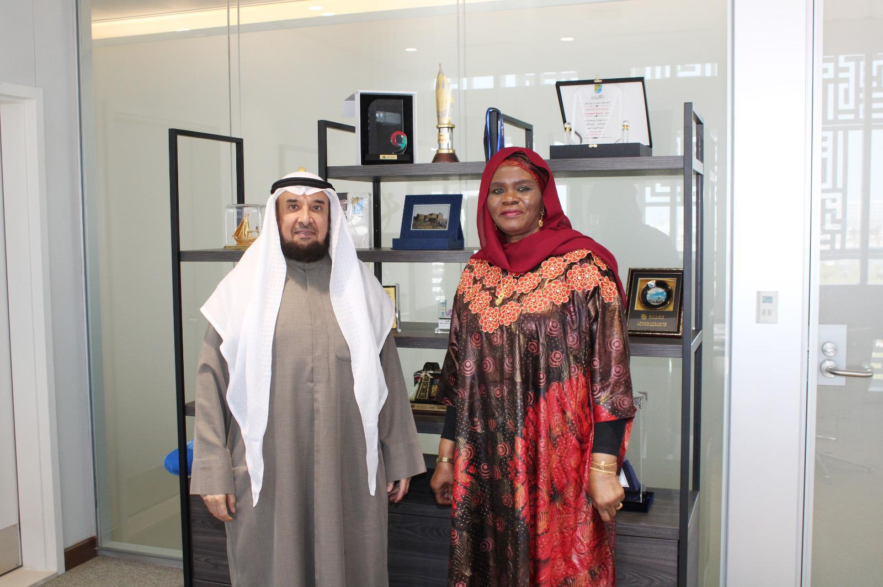

The two countries ratified the Education Agreement in 2021, allowing the State of Kuwait to allocate four scholarship slots annually to the Republic of Sierra Leone for eligible Sierra Leoneans to study in the State of Kuwait as part of the implementation of the agreement. Currently, Sierra Leone has only one student admitted to the University.

Conveying appreciation for the meeting, Ambassador Thomas explained President Dr Julius Maada Bio’s flagship Free Quality Education programme in his first term in office, which culminated in an unprecedented increase in enrolment. Given its impact, she added that the Free Quality Education programme has been subsumed into his Five (5) Big Game Changers agenda for his second term.

She spoke on a range of issues requiring the attention of the relevant authorities in the University. She explained that since the scholarship quota was allocated two years ago, Sierra Leoneans have been challenged to be admitted to the University.

Her Excellency also informed the Dean about the arduous task of certifying documents through Kuwait’s Embassy in Dakar, Senegal, stating that the State of Kuwait is yet to establish a resident diplomatic mission in Freetown, Sierra Leone, which had made it difficult to certify applicants’ documents through their embassy in Dakar.

“I wish to request your guidance in the criteria to study in various fields at the University. Additionally, I would be grateful if modalities are put in place to certify our applicants’ documents here in Kuwait. Postgraduate studies are also critical to His Excellency President Julius Maada Bio’s agenda for human capital development. We look forward to postgraduate programmes and also the University’s favourable consideration to providing more scholarships for Sierra Leoneans intending to study in various fields, including Science, Technology, Engineering and Mathematics (STEM), arts, social sciences, and Arabic Literature,” Ambassador Thomas stated.

In his response, Dr. Jassim Al-Hamdan, Dean of Students Affairs, welcomed the idea of admitting more Sierra Leonean students to Kuwait University, assuring of the University’s commitment to increasing the quota for Sierra Leone. He noted that the University would advise on the concerns discussed regarding criteria for admission and areas of study which will be officially communicated.

Ambassador Ishata also met with Professor Fayiz M. Aldhafeeri, Acting Secretary-General of Kuwait University, where they discussed initiating student and lecturer exchange programmes between the two countries.

Kuwait University is the State of Kuwait’s national university leading in higher education and scientific research. The University was established in 1966 as the state’s first public institution of higher education and research. It has made significant advances since its establishment nearly fifty years ago. It has evolved into a multi-faculty institution of higher education comprised of sixteen colleges offering ninety-two undergraduate and eighty-nine graduate programs.